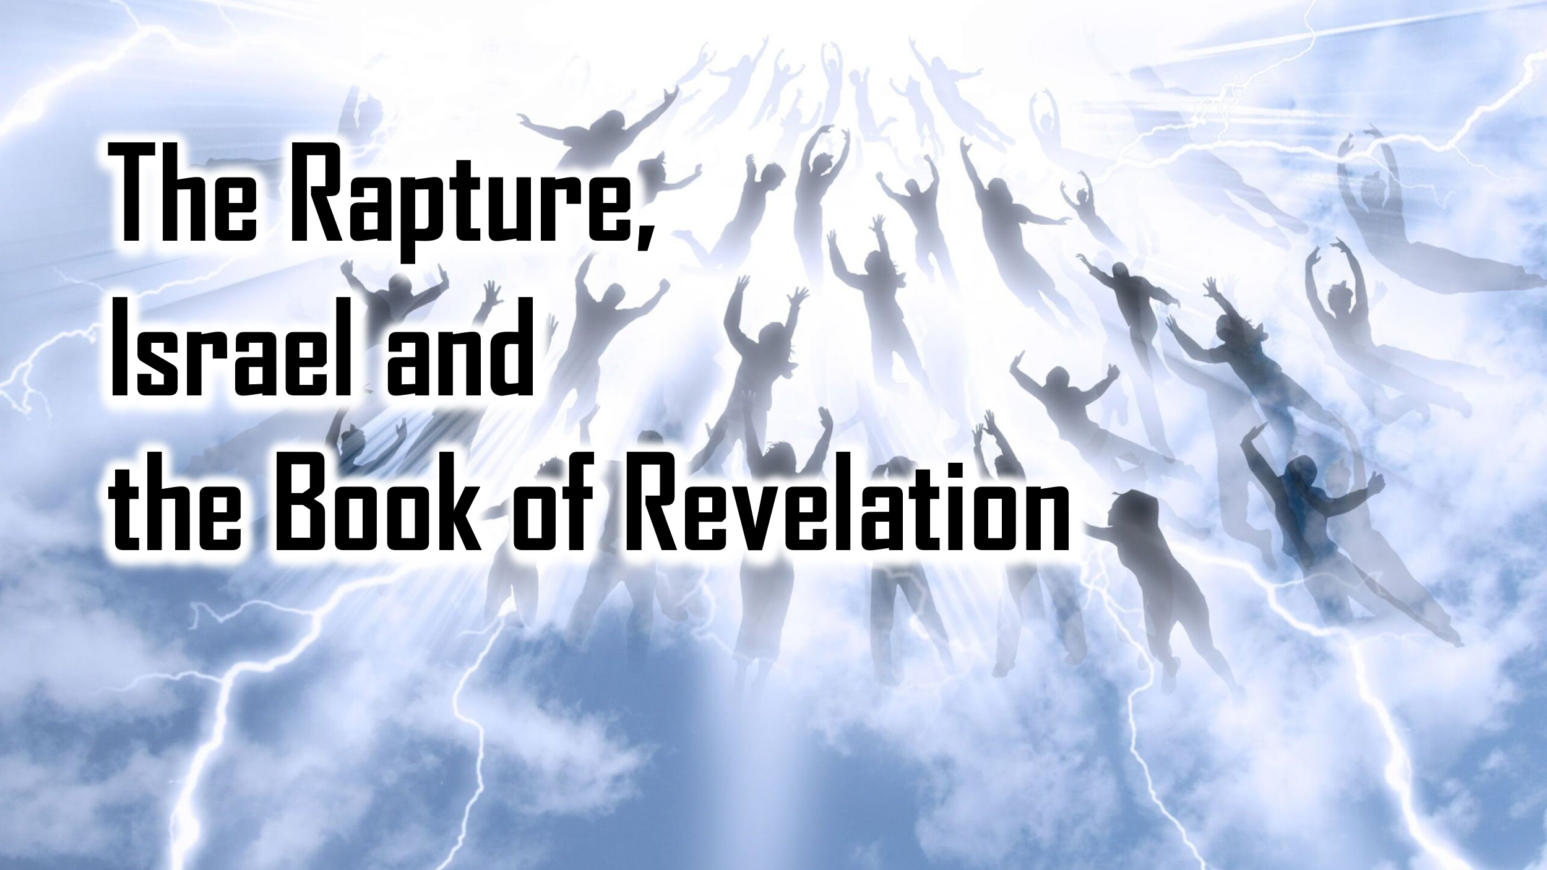

Study One: An Overview of Two End Times Views –
The “Great Disappearance” Rapture vs The Resurrection of All the Dead
January 14, 2024

I. Introduction: How do we respond to the new book The Great Disappearance by Dr David Jeremiah in the light of what we believe Scripture teaches about the End Times?

II. Biblical Basics about the End Times:

A. According to the Bible, what is the defining event of the end of the world?

- Matthew 24:29-31, 36

- John 5:25-29

- 1 Thessalonians 5:1-4

- Revelation 1:7

B. Why does God wait to bring the Last Day?

- Matthew 13:24-30

- 1 Timothy 2:3-6

- 2 Peter 3:8-13

What is the place of Jews, ethnic Israel, in God’s saving plan? Does He have a separate plan for them? Or is God’s patience for people to be saved through Christ the same plan for both Jews and Gentiles?

C. What is the “millennium”?

- Revelation 20:1-7

Are the 1000 years to be understood literally and chronologically? Or is this to be understood symbolically as apocalyptic imagery?

D. What is “the rapture”? (1 Thessalonians 4:17; Matthew 24:40-41)

- 1 Thessalonians 4:13-18 (“caught up”; Greek: arpazo; Latin: rapiemur => English “rapture”)

When does this being “caught up” with the Lord Jesus happen? Does this text say?

- Matthew 24:39-41

What does it mean to be “taken” or “left”?

III. The Two Main Views of the End Times

A. Dispensational Premillennialism (the rapture before a seven-year tribulation)

B. Amillennialism (The resurrection of all the dead at Christ’s coming to judge)

